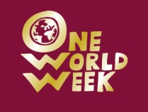
One World Week Quiz 2010 - Peacing Together One World
TEAM NAME............................................................................................................




1
2
3
4
5
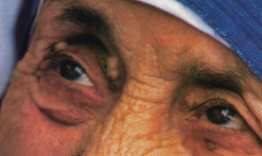

What does this symbol mean?
What TV programme is this symbol from?

Who is this?
What does this symbol stand for?
Who is this?
6
Which of these animals is endangered, which is extinct, and which is common?

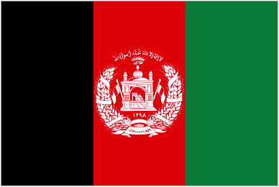
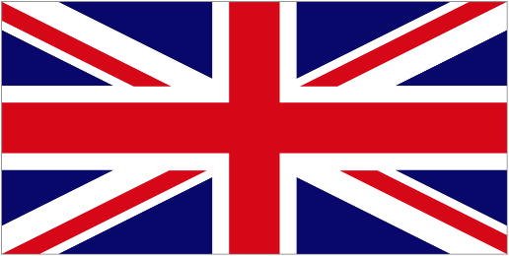
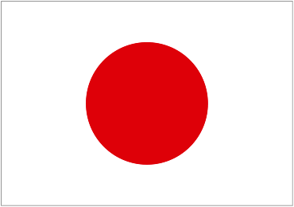
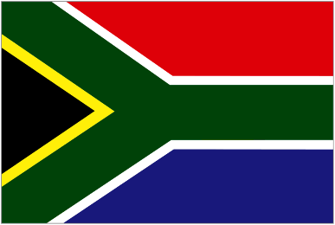
Name the countries that these flags are from

7
8
9
10

